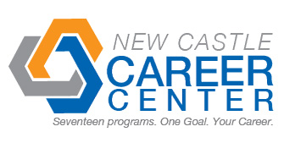
Student Profile
Name | Nicholas Radcliff
Address | 4849 West State Road 38 New Castle, IN 47362
Cell Number | (765)-533-3408 |  | Email |  |  | cdrman@comcast.net
Career Program | Pre-Engineering II
Certifications | Autodesk Inventor Certification- anticipated
Dual Credits | 2 Physics, 2 Trig, 3 Engineering, 3 anticipated Engineering
Attendance: Days Missed This Year | 0 | Reason for Absences |  | N/A
Graduation Date | 2014 | High School |  | Shenandoah High School
Employment Interest | Computers, engineering, hard work
Teacher Reference | Mr. Neal |  |  |  | Teacher Contact # |  | 765-593-6680
Past Employers | Pastor Jeremiah Clark, Mike Herrman, Grace Baptist Church, Agape Learning Center
Able to Pass  Drug Test | yes
Employer Notes about the Student

